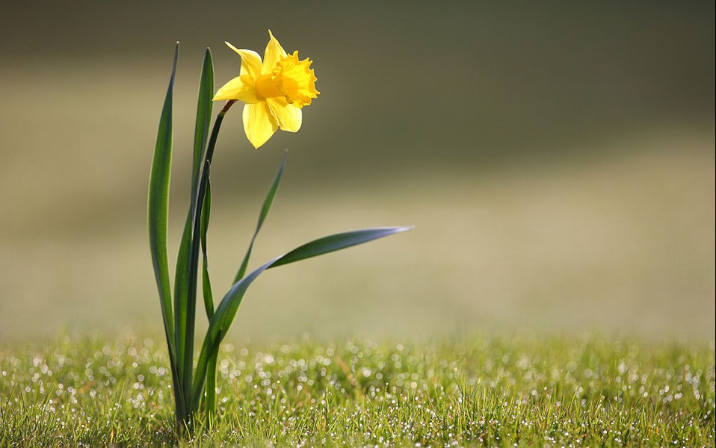
During our talk today we were reminded of our Hope that we have in Jesus and that fact that He needed time to step back and be still. We put together our thoughts about what we were beginning to see about us that reminded us of the hope within us:

Seeing the days draw out - snowdrops by the church in Lullington!

Fluffy pussy willow on the willow tree outside in our garden

Birdsong

Seeing people smiling and being positive despite the challenges of the pandemic

New grandchild arriving in May - we were not expecting any more!

Young lambs in the field jumping and playing

Blue tits checking out our nest box

Slightly warmer weather!

The willingness of so many people volunteering to deliver vaccines and other hope

Feeding the robins with my grandchildren

